

Credit Card Authorization Form

Name on Card: Scott Roberts
Company Name on order: Blake’s Hard Cider
Order # _________________________________________________
Email for receipt: scott.roberts@blakefarms.com
Type of Card: Visa _____ MC _____ AmEx _x__ Discover _____ Other: _________________

Account # 3794 060531 41000
Expiration Date: 09/25
Security Code: 4823
Billing Address 17985 Armada Center Road
City, State, Zip Code Armada, MI 48005
Phone Number: 734-674-0477
Product Total: ________________________________
Shipping Total: ________________________________
Charge Total: ___________________________________

Name Printed: Scott Roberts
Signature: 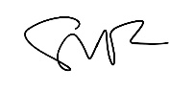
Date: 5/18/23

